**Accommodation**

The Hotel selected to host CiL 2014 delegates is:

**Fira Palace Hotel 4* (CONGRESS VENUE),** Av. Rius i Taulet, 1-3 , E-08004 Barcelona

[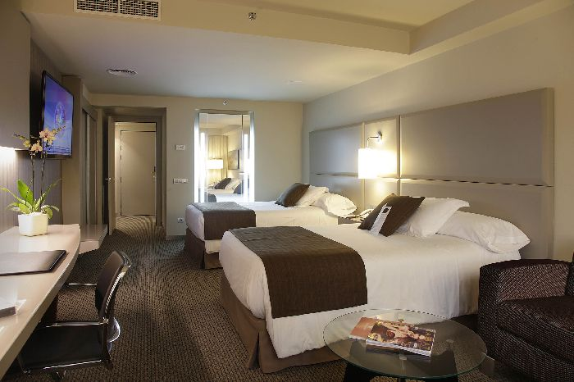](http://www.challengesinlaparoscopy.it/cil/wp-content/uploads/2012/07/deluxe_1.jpg)

Situated between the famous Plaza de España and Gran Via Avenue, in the heart of Barcelona, in an area with a wide cultural offer and excellent communications service to anywhere in the city and the airport.

Rates  
Deluxe Single Room: € 170,00  
Deluxe Double Room: € 190,00

Rates are per room and night with buffet breakfast and VAT 10% included. The accommodation rate DO NOT include the touristic city tax which is € 1,21 VAT included per person and should be paid at departure. Wi-Fi complimentary for clients staying in the hotel.  
In case of VAT and/or any tax modification, rates and prices will be updated accordingly.